NAME: EKENG, AKANINYENE IME
COURSE: WINDOWS FUNDAMENTAL 2 (CYBERSECURITY)
COHORT: NOVARA 28 NOVERMBER 2025
DATE: 18/12/2025

INTRODUCTION
This practical session focused on Windows Fundamentals 2 using the TryHackMe platform. The exercise provided deeper knowledge of the Windows operating system by exploring system configuration, advanced system settings, User Account Control (UAC), and various administrative tools. The session helped in understanding how Windows manages system performance, security, and monitoring through built-in utilities.

OBJECTIVES
The objectives of this practical session were to:
- Understand system configuration and advanced system settings
- Learn how to change User Account Control (UAC) settings
- Explore Computer Management tools
- View and analyze system information
- Monitor system performance using Resource Monitor
- Use Command Prompt for basic system operations
- Understand the purpose of the Registry Editor
PROCEDURES
The following steps were carried out during this practical session:
- I opened System Configuration (msconfig) to view startup options and boot settings.
- I accessed Advanced System Settings to check system performance, environment variables, and system protection.
- I modified UAC settings to understand how Windows controls administrative permissions.
- I opened Computer Management to manage users, disks, and system services.
- I viewed system details using System Information to check hardware and software resources.
- I used Resource Monitor to observe CPU, memory, disk, and network usage.
- I executed basic commands using the Command Prompt.
- I opened the Registry Editor to understand how Windows stores system configurations.

OBSERVATION
- I observed that System Configuration controls startup and boot processes.
- I observed that Advanced System Settings affect system performance and user environment.
- I observed that UAC helps prevent unauthorized system changes.
- I observed that Computer Management provides centralized administrative control.
- I observed that System Information displays detailed hardware and software data.
- I observed that Resource Monitor shows real-time system resource usage.
- I observed that Command Prompt allows direct interaction with the operating system.
- I observed that Registry Editor contains critical system configuration data and must be handled carefully.

OUTCOME
At the end of this practical session, I gained:
- Better understanding of Windows administrative tools
- Knowledge of system monitoring and configuration
- Improved awareness of Windows security features
- Practical skills useful for system aSdministration and cyber security tasks
CONCLUSION
The Windows Fundamentals 2 practical session successfully enhanced understanding of advanced Windows system tools and settings. Through hands-on exploration of system configuration, UAC, computer management, system monitoring, and command-line utilities, essential administrative and security skills were developed. This knowledge is important for effective system management and forms a strong foundation for cyber security and IT-related tasks. 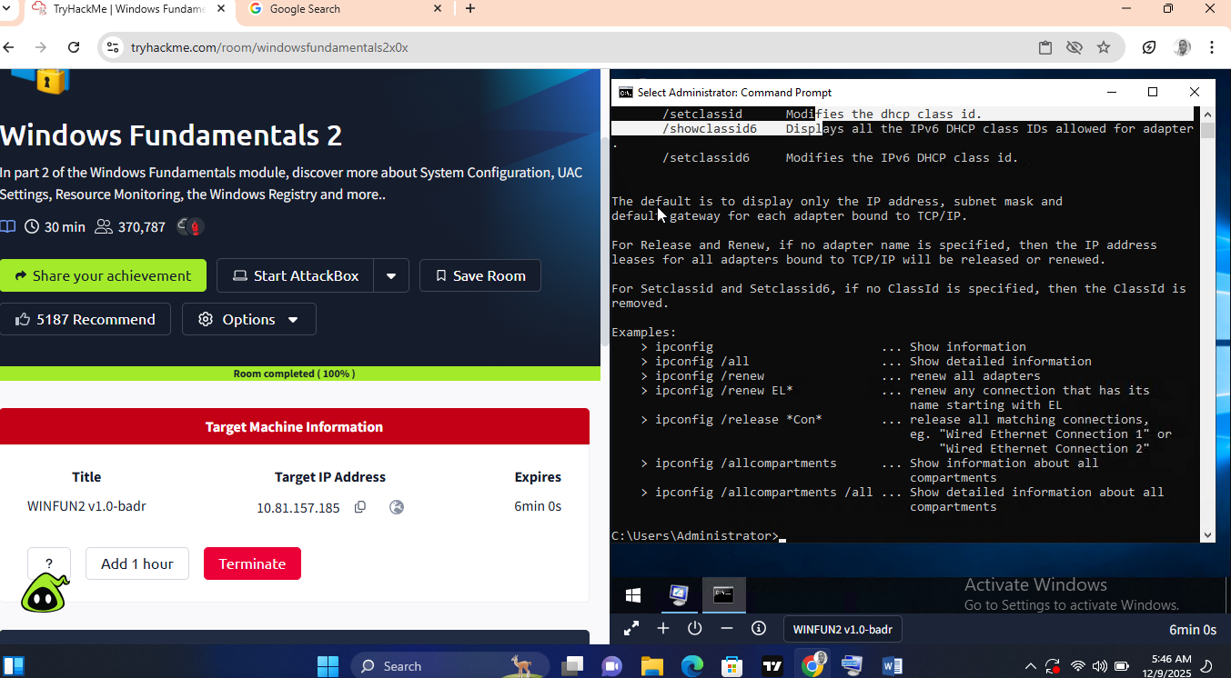

SCREENSHOT OF MY SUCCESSFUL COMPLETION

